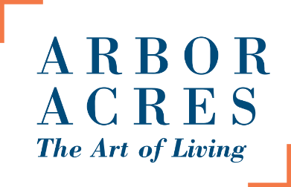
ARBOR ACRES UNITED METHODIST RETIREMENT COMMUNITY
Private Employee Information Sheet
For your protection and the protection of its residents, Arbor Acres must know who is on campus at all times. Please complete a copy of the following form in advance of your arrival, at Arbor Acres. Deliver a completed copy to the security officer, at the Welcome Center, each time you enter campus.
Company/Employer Name:___________________________________________________________
Caregiver Name:____________________________________________________________________
Physical Address:____________________________________________________________________
Email Address:_______________________________________________________________________
Contact Number:____________________________________________________________________
Auto Make/Model and Color:__________________________________________________________
License Tag:_________________________________________________________________________
Shift Time:_________________________________________________________________________
Resident Name and Address:___________________________________________________________
1. Do you have a cough or difficulty breathing?
Please Circle: YES NO
2. Have you had a fever of 100 degrees or higher?
Please Circle: YES NO
3. Have you been exposed to a person who has tested positive for COVID-19?
Please Circle: YES NO
4. Have you traveled to a high risk area?
Please Circle: YES NO
SIGNED: ___________________________________________________
PRINT NAME________________________________________________

